SAM WOODS, DAVID RULE, JAMES PROUDMAN, LYNDON NELSON
From: Marty Bonus (PRA), Jamie Coen (FSSR), Bill Francis (PPD), May Rostom (Research Hub)
predicting credit union failure using econometric methods
Summary
- We used econometric methods to help Supervisors identify, on a forward-looking basis, those Credit Unions that may be at risk of failure.
- We find that Credit Union default over a one-year period can be predicted with a small number of key variables, the most important of which were: asset holdings, capital ratio, unemployment, and the ratio of unsecured loans to assets.
- These findings validate key elements of Supervisory practice. They also highlight areas where certain Supervisory tools could be refined.
- We are also developing a tool that allows Supervisors to run our econometric model as needed. The purpose of the tool is to help Supervisors identify risky firms and to manage resource strain.
- Supervisors have provided us with very positive feedback in a number of meetings in which they were able to see and use the tool. Ongoing development and updating will be a collaborative project involving Supervision and SRDD staff.
- Further details are available in the Working Paper: filesite 7391946

Background
- Credit Unions (CUs) are small, non-profit financial institutions that are typically founded by an affinity group such as an employer or a local community.
- They an area of ongoing Supervisory focus and monitoring. This is because five to seven CUs fail every year, and because they are growing in average size (Charts 1 and 2).
- With the inclusion of Northern Ireland entities in 2012, the PRA now Supervises c.500 CUs – far too many to devote material resources to Supervising them all.
- To manage this resourcing challenge, Supervisors use a judgement-based tool – called Risk Profiler – that ranks the riskiness of firms based on key features of their current financial position.
- Econometric methods can be used to design a forward-looking model of CU failure. Such a model, used in conjunction with existing practice, would assist Supervisors to identify at-risk CUs and make resourcing decisions.
Methodology and Results
- We sourced data from the audited PRA annual returns (including Northern Ireland) from 2003 to 2015.
- From these data, and in line with the CAMEL frameworkof financial firm failure, we identified a number of variables that might predict CU failure.
- Failure was defined as full default and referral to the Financial Services Compensation Scheme (FSCS), although other definitions are possible.
- Nearly all CAMEL variables differed significantly between firms that defaulted and those that did not (survivors). The only exceptions were staff size, liquid asset ratio, and management expenses.
- The characteristics of failed firms vary by how far in advance failure is measured. For example, we see that total assets is a useful discriminator between failure and survival at all prediction periods, but return on assets is a less useful predictor over longer periods of time (Charts 3 and 4).
- Using probit regression techniques, we designed and tested a number of CAMEL-based models of CU failure. These models were tested for robustness and validity.
- Our preferred model uses six key variables to predict CU failure (Chart 5): five items from the PRA returns and national unemployment. Firms with greater asset holdings and better capital ratios are less likely to default, whilst elevated levels of national unemployment and high ratios of unsecured loans to assets are both positively linked to failure.
- These results will probably not surprise Supervisors, who already monitor some of these variables closely. However, membership size and liquidity ratio are also monitored by Supervisors, but these are not significant predictors of failure in the next year.
- We compared the risk ranking of firms, according to Risk Profiler and the econometric model, and found a statistically significant correlation between the two approaches.
Conclusions and next steps
- Our work provides independent validation of the Supervisory approach. It also points to potential refinements of current Supervisory tools.
- In line with Supervisory input, we are developing a tool to allow Supervisors to run this model themselves, varying the input variables and time periods. This tool would allow Supervisors to rank the forward-looking risk of CU failure in a statistically robust way. However, we note that all models have limitations, so Supervisory judgement will always be essential.
- We received from Supervisors very positive feedback at a number of sessions (Research Town Hall, bilaterals, etc.) where they were able to see and use the tool.
- We expect future development on the tool, as well as routine data updates, to be collaborations between Supervision and SRDD.
CHART 1: TOTAL CREDIT UNION ASSETS | CHART 2: NUMBER OF CREDIT UNIONS
CHART 3: TOTAL ASSET HOLDINGS OF DEFAULTERS AND SURVIVORS  Defaulters  Defaulters  Defaulters  Defaulters  Defaulters  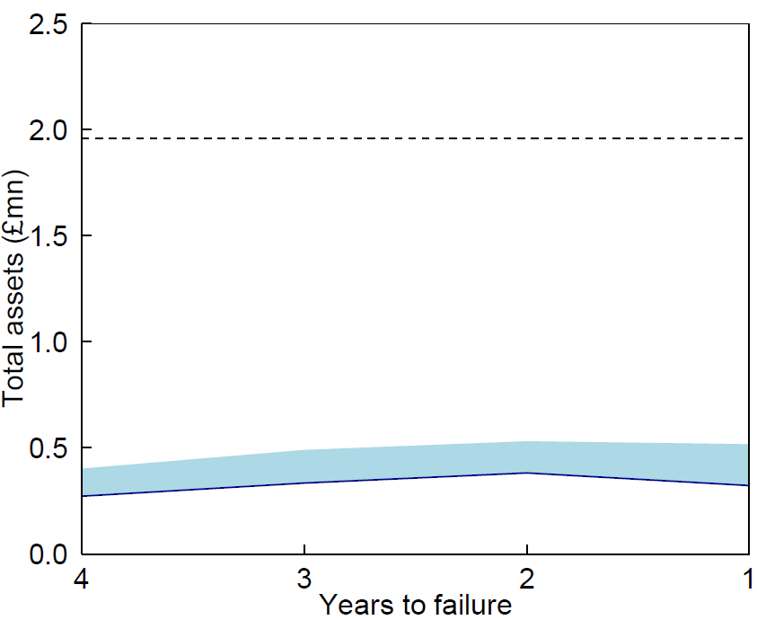  Defaulters  Survivors |  | CHART 4: RETURN ON ASSETS FOR DEFAULTERS AND SURVIVORS  Defaulters  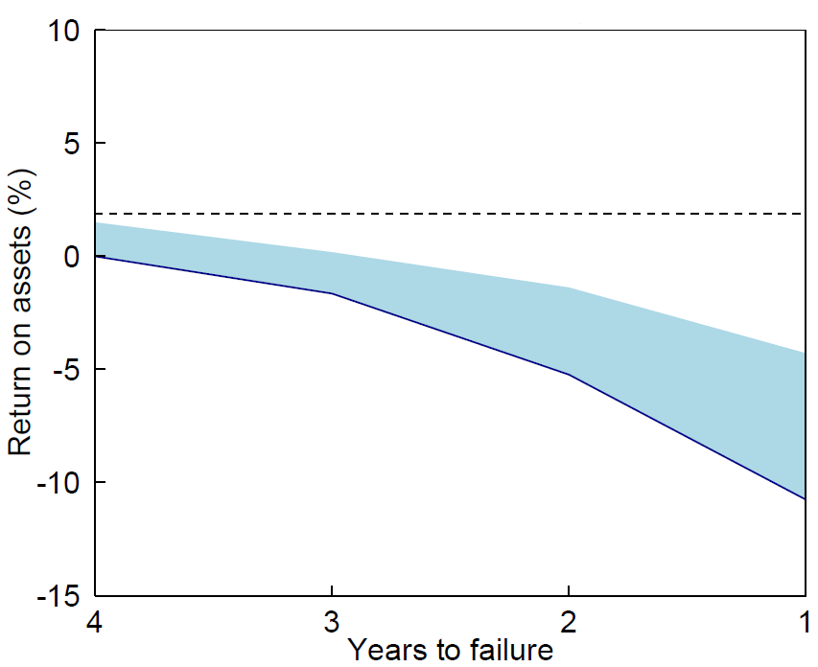  Defaulters  Survivors
CHART 5: PREDICTIVE POWER OF ECONOMETRIC VARIABLES

Appendix: Key Links
The Working Paper we drafted, along with a summarised Supervisor-friendly version are below:
Working Paper filesite 7391946
Supervisor-friendly summary of WP - filesite 3876554

We also examined periods of up to 5 years, but have focussed our analysis on the one-year period, in line with common risk metrics such as one-year VaR.
See the working paper for more background regarding the CAMEL framework. A link is provided in the Appendix.
For example, distressed takeover or a capital ratio under a certain level
The chart shows the change in default risk (in bps) that happens in response to 0.1 standard deviation change in a predictor variable. We work in deviations because the variables vary in size and in units (£, ratios, etc).

